**118COM Group Project**

**Online bookstore processing system--IZZ BookStore**

**Group No. 2**

Member Names and ID: Chan Yik Kit (56237852)

Chen Tak Hei (56226087)

Lai Justine (56235545)

Zachary Law Hong Chun (56237888)

Submission Deadline: 24th November 2020

#### 

#### Table of Contents

Company Overview **3**

Service Blueprint **3**

As-is versus to-be mapping **5**

Cost Benefit Analysis **6**

Service Catalogue **7**

Process Analysis **9**

Reference list **12**

#### 

#### Company Overview

IZZ Bookstore is an Hong Kong local online bookstore company hosting a website for book sales and flip. We are a 4 people Kickstarter company.

With the ongoing business environment of pandemic, potential customers would be more likely to stay at home and avoid shopping and do entertainment outside home. With this pattern occurring, the streets are less crowded and would have less flow of people on the streets to visit ground level shops and to purchase products, services. On the other hand, since people have more time to stay at home, online shopping has a huge boom on the sales trend, which would exceed the needs of physical shopping with much more benefits and safety measurements.

We are hosting an Online bookstore processing system website for any Hong Kong customer to view our book products to preview and purchase the books they need.

#### Service Blueprint

Under the circumstances of the pandemic, coronavirus will increase the difficulty for shopping, specifically physical store shopping. Factors including the high risk of infection, the cost and steps for measurements of preventing inflection. Solution to this is where online shopping comes into play. Our team has scoped this market demand and to provide a great service with a high range of variety features which would benefit Hong Kongers with any relationship with books.

Our company would provide the service of an online bookstore website, a local exchange store where we would trade between each other's book or purchase direct first hand books from suppliers. With a wide variety and options for customers to choose from, customers can gain the best experience with the best deals.

With features such as these, we aim to target customers in Hong Kong as for now, would add consideration to expand to mainland China and furthermore in Asia. We hope for a great expedition of our website server and to support other countries and more book storage for region coverage.

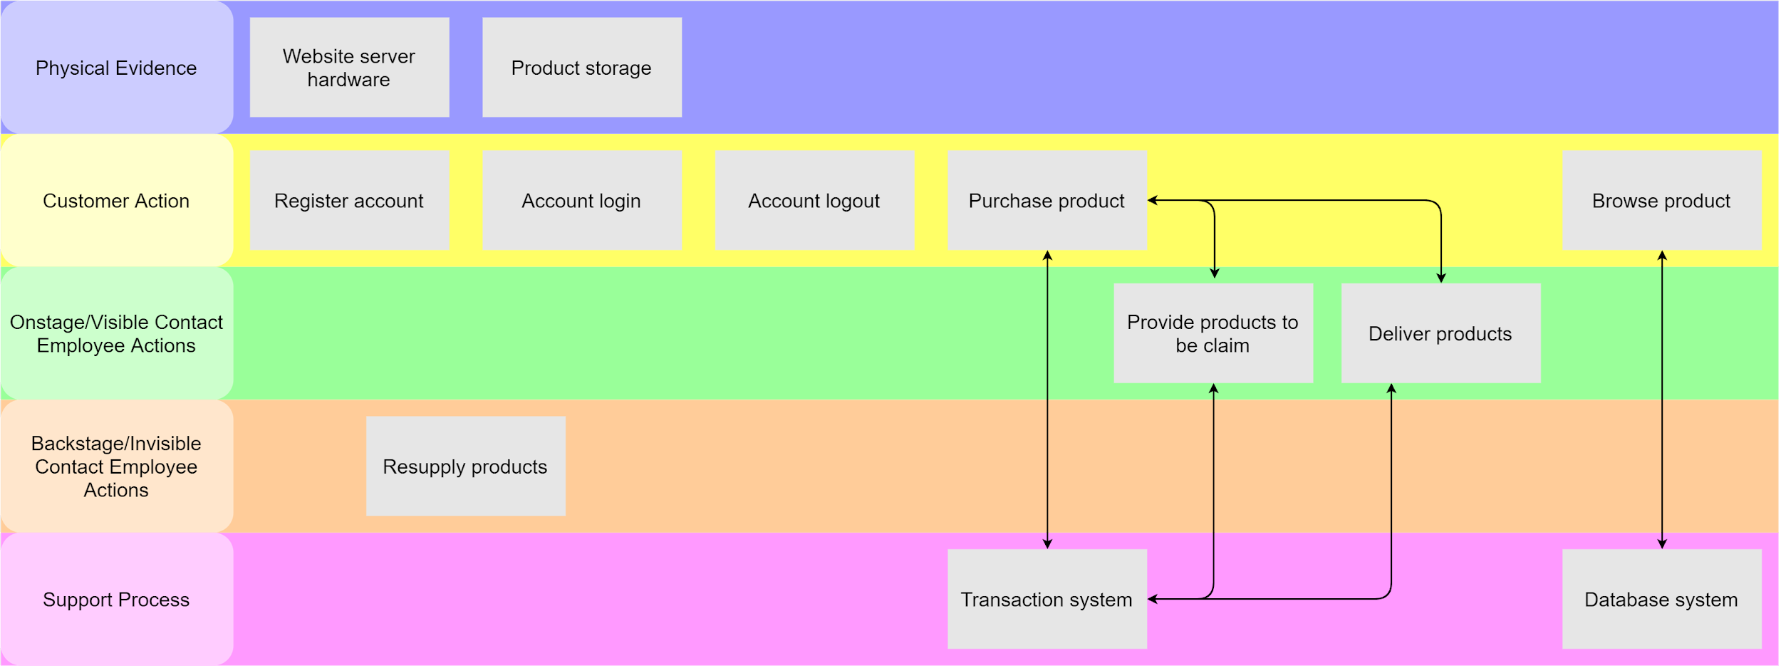

Proposed application overview

Our page website has a book library gallery with basic book preview and details, a user login system along with an account creation page, a shopping cart with payment and check out feature, plus a customer side submit book order submission page. This application provides a multi feature platform for book exchange and transaction for Hong Kong book lovers to use and to share their favorite book.

With this application would bring to our company a huge contribution value. It covers the Hong Kong citizen marketing potential meaning 7.4 million population in exchange for high density population for greater delivery cost efficiency too. The cost for hosting the website server would be extremely low relative to physical street shops. Moreover, the application has a flexible business model which can implement a subscribers system for quick and high priority for purchasing books that come with a small price to pay as one of features of future plans.

With this small manageable application system would greatly benefit the company economy and financial situation. Once the application is self-sustainable and in a stable situation, we would expand our service coverage from Hong Kong to mainland China for more potential customers for any book lovers. In the meantime, we would carefully analyze our server traffic load and provide adjusted measurements onto the website hosting server for durable and consistent hosting for mainland China future clients. And we will look forward to our application website.

#### As-is versus to-be mapping

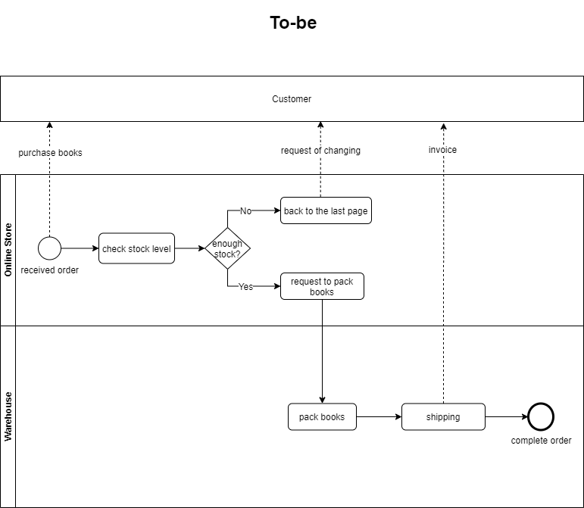

#### Cost Benefit Analysis

From the above table, you can see the total expenses in the first month is really high. It is because the start-up cost for what we need to run our online bookstore is essential. The non-recurring cost for the first month is high as we will buy two servers. The reason why we would like to buy two servers is because when one of them is not working properly, there is a backup server. This action will help us to prevent losing of all the data in our database. Besides, we will buy some basic furniture such as desks and chairs. These will be included in the non-recurring cost because we just need to buy once until it cannot be used anymore.

As shown in the above table, our business is in the red until the fifth month. In the first few months, there may not many citizens will know us. Therefore, the profit cannot cover our expenses. To solve this problem, we will spend money on advertisement, broaden our products and reduce labor cost. We will promote our business through newspaper, magazines and the internet (e.g. Facebook, Instagram) to target different people. We will sell many unique books collected from around the world. For example, we will sell different books in different languages. We found that most of the bookstores just sell books in English or Chinese. However, Hong Kong is an international city. Hong Kong has people from different countries lived in. These kinds of books can let them have home feeling especially in this hard time for everyone. These books can also help people who want to learn foreign languages to broaden their horizon. We did not hire any staff to organize the warehouse and books in order to reduce cost. We will manage it all by ourselves until our business is expended.

We assume the income of our business will be positive after five months of red and the benefit cost ratio can be larger than 1 in the near future. We hope our marketing strategies and the uniqueness of our bookstore can attract more potential customers and expand our business worldwide. When the development and expansion of our business is growing, we will certainly need to upgrade our website hosting plan.

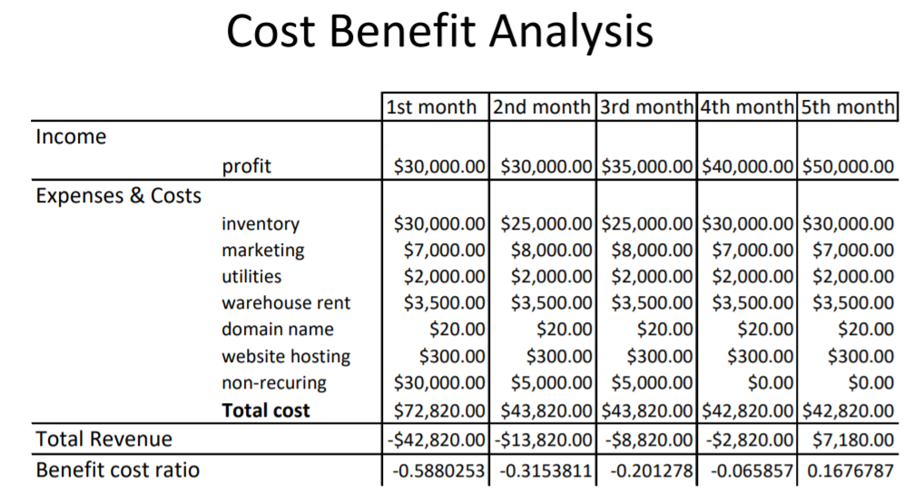

#### Service Catalogue

Each service is described in this catalog using the following elements:

|  |  |
| --- | --- |
| Element | Description |
| Service | Online IZZ Bookstore Processing System |
| Status | PROPOSED |
| Description | Provides a secure and convenient way to our customer for searching our products available, purchase our products online |
| Standard  Service Features | Provides up to hundred of book items with descriptions upload in the website for customers to search  Provides shopping cart and wishlist to save the desired books  Purchase books online via PayPal/ Visa/ Mastercard  Collect bought books in the physical store in person  Collect online second-hand book application form the individual customer (provider)*, and we will check whether the book condition is suitable to sell or for recycle  *The provider can either choose to donate the book or receive a commission after the book can sell to the customer by us. However, it depends on the condition of the book, if the book fails in our book conditional checking, we will only accept the provider to donate and the book will be recycled afterwards.  Other standard services include:  Account user ID or password change  Personal information change (e.g. user address, phone number, email address) |
| Optional  Service Features | Request additional book order to us by email  Collect bought products via delivery to the designated location requested by the customer |
| Delivery Scope | Available in online  Require users to register an individual account in the book processing system first |
| Delivery Channels | Spec. A device with a stable network connection |
| Service Hours | 24/7/365 (Online) |
| User Requirements | A login account  A valid credit card, or other acceptable payment method |
| Service Initiation | Account Registration Online  Payment method Validation online |
| Service Support | Email, Telephone enquiries, and Help desk support in the physical store |
| Standard Costs | Initial system set-up: Low  Running Costs: Low  Customer Costs: None |
| Optional Costs | None |

Benefits of employing service catalog:

The Service Catalogue includes various types of elements with detailed descriptions which gives a clear view of what our services will provide to our customers. Including what features will we provide, what are the prerequisites to use the system, and also how can we support the customers when problems arise and they are trying to seek help. Therefore, this Service Catalogue is useful to give us information about what services are expected to provide to our customers.

#### Process Analysis

The above diagram displays those key events while a customer is visiting our website to display the whole flow of the production system. The processing mechanism for the online bookstore will operate as follows: first by entering the registered password and user ID, after the system validates it, customers will search for the book they are interested in by using the ISBN book, name, publisher, or author. It is failing to buy if no results are running out or showing there is no inventory recently. In the other case, customers successfully find their book if there are results printed out, they can proceed to the shopping cart and to do the payment, choosing the delivery method, and receiving a confirmed email. Customers can also save the searching result or their interest books to the wish list and favorite list first for later purchases and can also be a shopping record.

In addition, the movement from staff to publisher (supplier) and clients. Staff responsibilities include handling client orders, periodically reviewing inventory, and checking new inventories. Firstly, workers have to address the purchase request recording from the processing system and database, send the verified email to the target client, plan the bill note, and eventually arrange the delivery service. If there is already out of stock in the daily check-up stage, staff need to contact our supplier using the database records. Order, buy, and restock books from vendors, often while doing a broad demand for purchasing, after paying bills, may obtain a discount, eventually updating the list of device items.

According to the activity, the diagram decrypted the main flow of the whole system of different parts and characters. Users require an account to browse for goods and order them. The server needs to configure the customer’s account, display those orders and transactions. Staff would also have an account to build orders, search the store, and manage the distribution from a customer to the provider. The administrator primarily controls those accounts and helps to control system processing. It was important to contact manufacturers to supply and provide us with inventories. This is the key loop processing device for online bookstores.

Alternatively, a second-hand book, it is partly different compared with a first-hand book. First, it is second-hand which means those books have been read and brought by someone for a period of years. There may be yellow pages, battered pages or even missing pages. Some may smell horribly, handwritten by someone else and dusty. Therefore, the stage of filtering those second-hand books by a standard quality criteria is necessary for providing the consummate service quality. After that, a failed one will return to the provider but those suitable books will be contacted and received by the bookstore to process the selling stage. Providers can choose to donate the book or to receive the commission by selling it on IZZBookstore.

|  |  |  |  |  |
| --- | --- | --- | --- | --- |
| Step | Step Name | Processing Time | Wait Time | Remarks |
| A | Customer making an order for a book or check out the shopping cart and the website receive the order | 5 minutes | 10 minutes | Customers need to first register the account and activate the log-in function to browse and shop on the web. He/she may need to spend at least 10 minutes to do this and make an order before our system receives the process. |
| B | Staff of our online bookstore system is going to manage the order and check up about the stock. System will manually calculate the total price of the order and proceed it to the payment stage. | 1 minutes | 5 minutes | The system will automatically calculate the total price rapidly. Customers can browse other books if they like within the waiting time of staff making the proceeding. |
| C | The order details, payment confirmation and delivery details will be sent to the customer's email for validation. | 5 minutes | 5 minutes | Personal information is needed for customer’s ordering and delivery from the database. It needs a while to wait for the email system to send the messages. |
| D | Customers accept and do the payment through email and payment platforms. System or staff receive the money and send the customer receipt through email. Then proceed to the delivery stage. | 15 minutes | 1 hour | The payment and money receivable need to wait for a while by bank processing. After that the system needs to write and send the customer receipt to the customer. |
| E | The book(s) is packaged and prepared. Staff need to contact the right courier to deliver the stock to the customer address provided by him/her. | 10 minutes | 1 - 2 days | Couriers need time to deliver those products and it also bases on the distance of the customer address. |
| F | Customers receive their ordered product and sign the acknowledge receipt. All transactions finished. | 2 minutes | 2 minutes | Couriers will receive the details and sign blank from us and they need to share the acknowledgement with us. |

The above timeline shows the transaction from online bookstore to customer.

Total Processing Time: 5+1+5+15+10+2 = 38 minutes(maximum)

Total Waiting Time: 10+5+5+(1 hr)+(1-2 days)+2 = (maximum) 49 hours 22 minutes

(minimum) 25 hours 22 minutes

Reviewing the processing, of course, there are more steps needed to fix and evaluate after the implementation of our online bookstore processing system. The above timeline mainly shows the action which from the first time register the account til brought a book and received it by a customer. Result to the timeline, there is a total 38 minutes processing time. It is the maximum, the average would be lower as customers will have faster logging after the first time as they do not need to register again. Also, the browsing time of the customer is hard to estimate and calculate before the implementation. The 1 hour and 1 to 2 days of total waiting time is mainly cost at the bank status checkup and delivery.

#### 

#### Reference list

#### L. (2017, November 13). *The Pros and Cons of Second-Hand Books*. Boats Against The Current. <https://boatsagainstthecurrent.net/the-pros-and-cons-of-second-hand-books/>

#### Appendix

##### Service Level Agreement

**Service Level Agreement (SLA)**

**for *Customer***

**by**

IZZ Bookstore

**Effective Date: 13-11-2020**

|  |  |
| --- | --- |
| **Document Owner:** | IZZ Bookstore |

**Version**

|  |  |  |  |
| --- | --- | --- | --- |
| **Version** | **Date** | **Description** | **Author** |
| 1.0 | 13-11-2020 | Service Level Agreement | Amy Chan Yik Kit |
| 1.1 | 14-11-2020 | Service Level Agreement Revised | Amy Chan Yik Kit |
|  |  |  |  |

**Approval**

*(By signing below, all Approvers agree to all terms and conditions outlined in this Agreement.)*

|  |  |  |  |
| --- | --- | --- | --- |
| **Approvers** | **Role** | **Signed** | **Approval Date** |
| IZZ Bookstore | Service Provider |  | 14-11-2020 |
| Customer | Customer |  | 14-11-2020 |

**Table of Contents**

1.Agreement Overview

2.Goals & Objectives

3.Stakeholders

4.Periodic Review

5.Service Agreement

5.1.Service Scope

5.2.Customer Requirements

5.3.Service Provider Requirements

5.4.Service Assumptions

6.Service Management

6.1.Service Availability

6.2.Service Requests

1. 分頁符號
2. **Agreement Overview**

This Arrangement forms a Service Level Agreement ('SLA' or 'Agreement') between IZZ Bookstore and the customer for the procurement of the IT services necessary to sustain and manage the online book shopping service and the sale of our books.

This Agreement shall remain effective until the amended Agreement, mutually accepted by the interested parties, has been superseded.

This Agreement outlines the parameters of all IT services covered as they are mutually understood by the primary stakeholders. This Resolution shall not supersede, unless expressly specified herein, the existing processes and procedures.

1. **Goals & Objectives**

The key purpose of this Agreement is to ensure that sufficient elements and commitments are in order to ensure that IZZ Bookstore offers reliable IT operation support and distribution to consumers.

The object of this Agreement is to achieve a reciprocal agreement between IZZ Bookstore and the Customers for the provision of IT services.

The objectives of this Agreement are:

* Provide direct reference to the ownership, liability, functions and/or duties of facilities.
* Present the consumer with a simple, succinct and observable summary of service provision.
* Align expectations of planned provision of service with real support & execution of service

1. **Stakeholders**

As the basis of the Arrangement, the following service provider(s) and customer(s) will be used and will represent the key parties involved with this SLA:

**IT Service Provider(s):** IZZ Bookstore (“Provider”)

**IT Customer(s):** Customer(“Customer”)

1. 分頁符號
2. **Periodic Review**

This Agreement is binding until further notice and is valid from the Effective Date outlined herein. This Agreement should be reviewed at a minimum once per fiscal year; however, in lieu of a review during any period specified, the current Agreement will remain in effect.

It is the responsibility of the Business Relationship Manager ("Document Owner") is responsible to reviews this document frequently. If consensus consent is reached from the key stakeholders and conveyed to all involved parties, the content of this document can be updated as needed. Any subsequent changes will be incorporated by the Document Owner and mutual agreements/approvals as needed will be obtained.

**Business Relationship Manager:** IZZ Bookstore

**Review Period:** Bi-Yearly (6 months)

**Previous Review Date:** 14-11-2020

**Next Review Date:** 14-11-2021

1. **Service Agreement**

The following detailed service parameters are the responsibility of IZZ Bookstore in the ongoing support of this Agreement.

1. Service Scope

The following Services shall be subject to this Agreement;

* Online first-hand book selling
* Second-hand book transferring and selling
* Manned support for the telephone
* Email Support tracked
* Mobile Remote Desktop and Virtual Private Network Assistance where required
* Onsite aid planned or emergency (extra costs apply)
* Monthly system audit on the device

1. *分頁符號*
2. Customer Requirements

Support of this Arrangement, customer obligations and/or specifications include:

* Credit at the agreed interval with all the service expenses.
* Fair customer representative(s) availability when handling an event or grievance relevant to a facility.

1. Service Provider Requirements

**IZZ Bookstore** responsibilities and/or requirements in support of this Agreement include:

* Meeting turnaround times correlated with accidents affecting the operation.
* Appropriate Customer Notice for all planned repairs.

1. Service Assumptions

Assumptions relevant to and/or elements of in-scope facilities include:

* To all clients, improvements to programs will be shared, reported and recorded.

1. 分頁符號
2. **Service Management**

Efficient in-scope service support is the product of ensuring reliable standards of service. Specific information on the availability of the program, tracking of in-scope resources and relevant components are given in the following pages.

1. Service Availability

Parameters of coverage applicable to the service(s) covered by this Arrangement shall be as follows:

* Support by phone: 9:00 A.M. Up to 5:00 P.M. Monday through Friday
* Calls received out of working hours will be sent to a cell phone and best attempts will be made to answer the call/action, but a contingency response phone service will be required.

* Support email: Tracked at 9:00 a.m. Up to 5:00 P.M. Monday through Friday

* It can gather emails collected after office hours, but no intervention can be guaranteed until the next working day.

Guaranteed onsite support within 72 hours of the working week

1. Service Requests

IZZ Bookstore shall respond to service-related events and/or demands made by the customer within the following timeframes in respect of the services outlined in this Agreement:

* 0-8 hours for problems listed as High Priority (during business hours).
* For concerns listed as Medium Priority within 48 hours.
* For problems listed as low priority, within 5 working days.

Remote assistance will be given based on the priority of the service request, in accordance with the above timescale.